# Assignment 1

By

Christoffer Wikner (931012)

Erik Rosvall (960523)

1

a)

Data taken from 2014 in order to include all countries. It is assumed that any changes in relationship between GDP/capita and life expectancy in the past 7 years would require a more thorough investigation than would be revealed in the scope of this assignment.

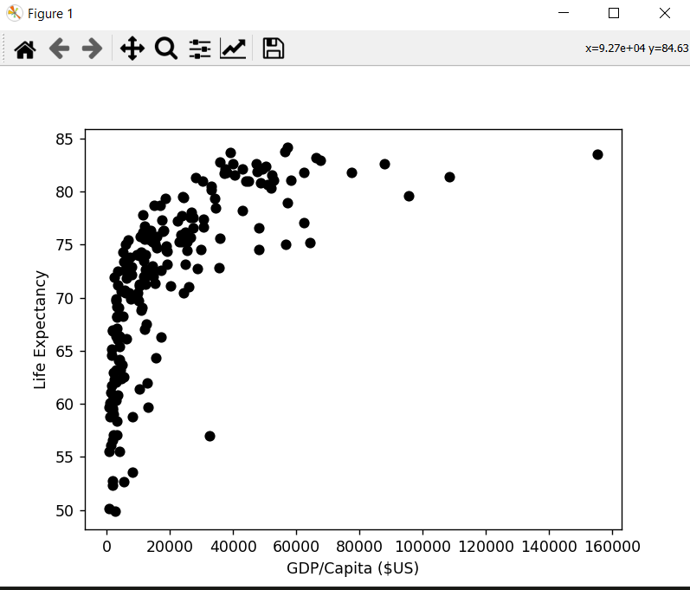

b)

The results shown in Figure 1 indicate a steep climb in life expectancy when increasing GDP/capita from 0 to 20000 $US. There is then a flatter incline from 20000 $US and up. A plausible explanation for this is that as a person gets older the more expensive it is to prevent, treat, and cure the ailments they suffer. It is also the case that things like food, clean water, and vaccines tend to increase life expectancy greatly; and are in the big picture fairly cheap compared to e.g. brain surgery to remove cancer.

The only outlier is Equatorial Guinea with a GDP/capita of 32436 $US and a life expectancy of 57 years. This can be explained in large part by Equatorial Guinea being the largest producer of oil in sub-Saharan Africa and the prevalence of disease and hunger. We expect Equatorial Guinea to regress to the mean over the foreseeable future.

c)

We did not for reasons discussed in (b).

d)

Life expectancy mean = 72,65

Life expectancy standard deviation = 7.89

Mean + 1*Standard deviation = 80.54

Countries with a life expectancy greater than 80.54:

Germany, Isle of Man, Falkland Islands, Belgium, Saint Martin (French part), Tokelau, Saint Barthlemy, Guadeloupe, United Kingdom, Portugal, Finland, Ireland, Austria, Anguilla, Greece, Luxembourg, Martinique, Netherlands, New Zealand, Malta, Norway, South Korea, Bermuda, Canada, Liechtenstein, France, Sweden, Israel, Channel Island, Iceland, Australia, Italy, Singapore, Spain, Andorra, Switzerland, Cayman Island, Macao, Japan, Hong Kong, San Marino, Monaco

e)

We arbitrarily interpret "high life expectancy but have low GDP" to mean a life expectancy greater than 75 and a GDP/capita of under 15000 $US. The following countries fulfill the given criteria:

Albania, China, Sri Lanka, Vietnam, Iran, Colombia, Algeria, North Macedonia, Morocco, Saint Lucia, Peru, Tunisia, Bosnia and Herzegovina, Ecuador

f)

If GDP/capita were a good indicator of economic strength the Chairman of the Federal Reserve would simply turn on the money printers at the first indication of an economic downturn. As such we refrain from making any loose judgments of a country's economic strength based on GDP/capita.

g)

Yes; every country with a GDP/capita over 80000 $US has a life expectancy greater than 78; which we consider to be reasonable cutoffs for both high GDP/capita and life expectancy.

2

a)

We chose the two data sets 'Self Reported Happiness' and 'Corruption Perception'. Unlike determining if you are alive or not as is the question at hand when dealing with life expectancy; both happiness and corruption involve a great deal of subjectivity and individual judgement. As such the data at hand can merely provide a loose indication as to whether a correlation exists and if so whether it is positive or negative. We also expect perceived happiness and corruption to be heavily dependent on comparees in the environment of the subject and thus expect the data to show a stronger correlation than is reflected in reality.

We have not culled any data.

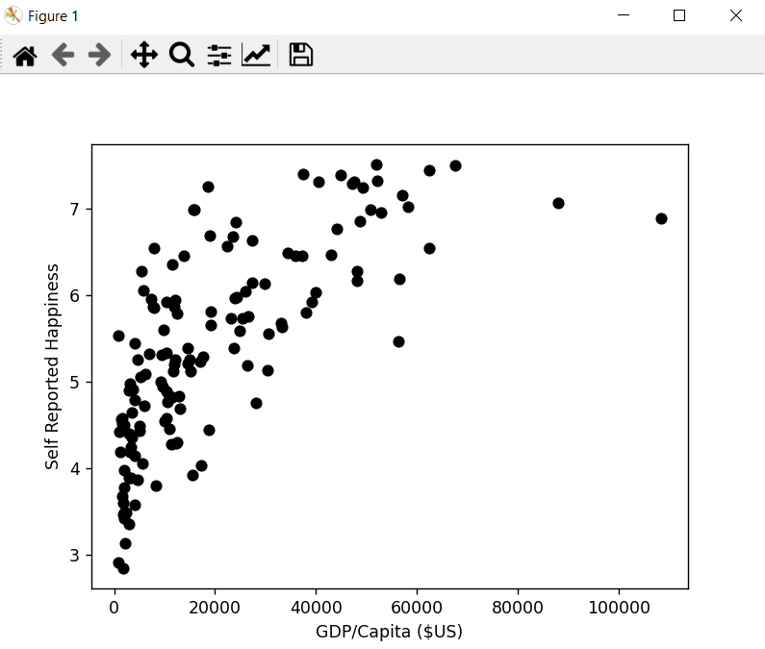

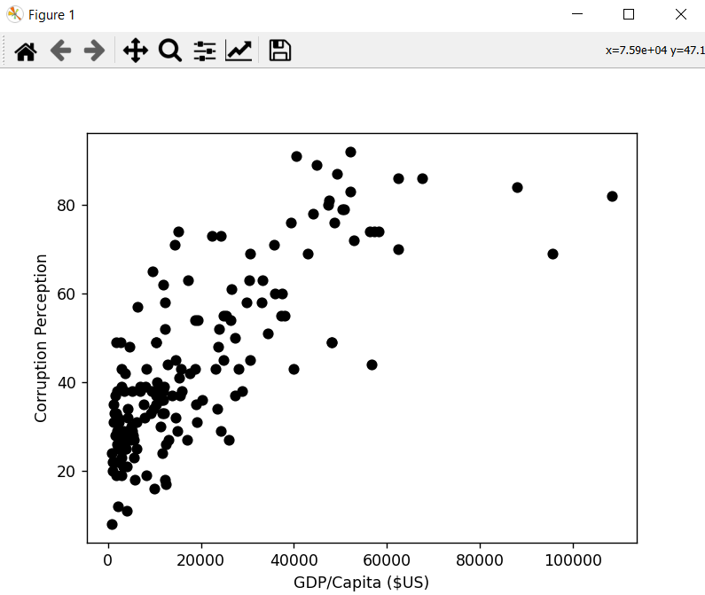

b)

In both cases we find a clear but very loose positive correlation with GDP/capita. However the variation within any given strata of GDP/capita represents a significant percentage of the variation of the entire data set. While it is possible in both cases to make a fairly accurate estimate of the lower bound of happiness and corruption given a country's GDP/capita; any prediction as to the actual value would carry a low degree of confidence.